2017-2018 Student Success Leaders Selection Timeline
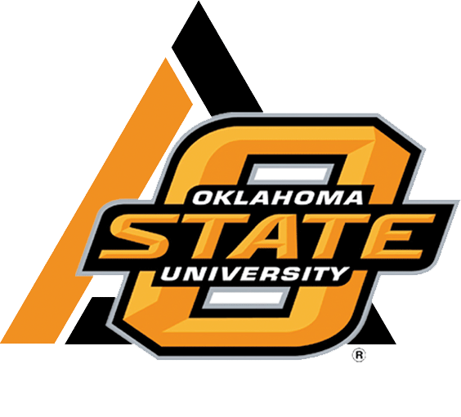

February 1, 2017 | - Student Success Leader Application becomes available (Online at casnr.okstate.edu)  Application located in the “CASNR Applications Corner” under the Current Students menu for all positions: CASNR Ambassadors, Career Liaisons, FIT SAMs, AG 1011 SAMs, and SCOUTs.  - Student Success Leaders Applicant Mixer sign-ups become available (103 Ag Hall)  These receptions are part of the screening and selection process for Student Success Leaders. All CASNR Ambassadors, Career Liaisons, and FIT SAM candidates are required to attend one of the selection receptions. AG 1011 and SCOUT candidates are not required to attend the receptions. A make-up assignment will be available for those with unavoidable conflicts; please notify the Student Success Center, 103 Ag Hall, in advance of a conflict, if at all possible.  Limited participation spots are available for each reception time. Reservations for candidate reception participation will be honored on a first-come-first-serve basis.  - Students with questions about the application and selection processes may schedule a time with one of the Student Success Center Coordinators to further learn about the opportunities.
February 17, 2017 | - Student Success Leader Application Deadline  Online submission required before 5:00 p.m.  - Student Success Leaders Applicant Mixer Sign-up Deadline  In person sign ups (103 Ag Hall) required before 5:00 p.m. for all CASNR Ambassadors, Career Liaisons, and FIT SAM candidates.
February 23, 2017 | - Student Success Leader Applicant Mixer  7:00 a.m. – 9:00 a.m. OR 5:00-7:00 p.m. (as determined by sign up before February 17th)  101 Wes Watkins Center  Dress: Business Professional
February 27, 2017 | - SSL Interview Candidates announced via email.  Candidates selected for an interview should promptly stop by 103 Ag Hall to sign up for an interview time.  Interviews are only conducted for positions of CASNR Ambassador, Career Liaison, and FIT SAM.
March 1-3, 2017 | - Student Success Leader Interviews  Dress: Business Professional
March 21, 2017 (tentative) | - Student Success Leader applicants notified of selection status through email– accepted, alternate or declined.
Week of April 3, 2017 | - Mandatory Student Success Leader Professional Headshots  Sign up for an available time slot as directed by Coordinators via email.  Location: Ag Communications Studio, Ag Hall North  Dress: Business Professional (from waist up)
April 27, 2017 | - Joint Meetings of 2016-17 and 2017-18 Teams  CASNR Ambassador, Career Liaison, and FIT SAM teams only  5:15 p.m.  Location: TBD, dependent upon team  Dress: Student casual
Please hold the training dates listed below associated with each of the positions for which you intend to apply; specific times will be determined as the dates approach. Training dates are mandatory. Students with potential conflicts need to contact the advisor.

CASNR Career Liaison Training: March 23-25, 2017
All CASNR Student Success Leader
Retreat & Training: August 25-27, 2017
AG 1011 SAM Training: August 19-20, 2017
AG 3011 SCOUT Training: August 17, 2017

Applicant Specifications:
- Currently pursuing an academic major within CASNR, and continued work towards a CASNR major throughout 2017-2018 academic year
- 3.0 cumulative GPA at beginning of term of service and maintained throughout 2017-2018 academic year; semester GPA below 2.75 shall result in probationary status.
- At least 12 hours of earned college credit by beginning of 2017-2018 academic year (Ambassador candidates must have at least 12 hours earned at OSU-Stillwater)

