Treatment Record for Groups of Cattle

Name of Farm/Ranch Pasture or Group Breed(s)

Number of steers______Tag numbers Number of heifers______Tag numbers

Range of Birth Dates Weaning Date Sale Date Buyer(s)
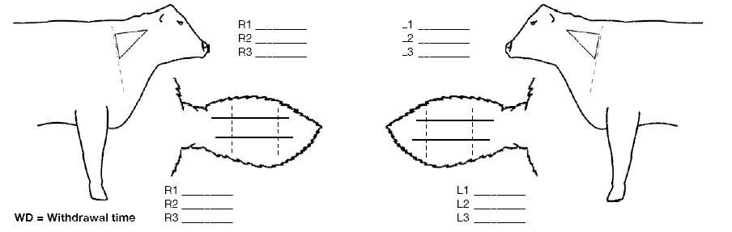

Date Treated  Cattle Treated | Product | Lot Numbers | Number of Doses Given | Route of Administration | WD date | Person Giving Treatment

