GROUP PROCESSING / TREATMENT MAP
Select SQ products and never
give an injection in the rear leg or top butt.

Group:____________ Date:_____________ ID: Rt. Ear/ Lft Ear: ____________

Booster/Reprocess Date:_____________ Pen/Pasture #: ____________

Class: S / H / Bulls / Cows Age:_____ Weight:_________ Hd. Processed ________

Other Management (√): Castrate___ Dehorn ___ Other ___________ Crew _________

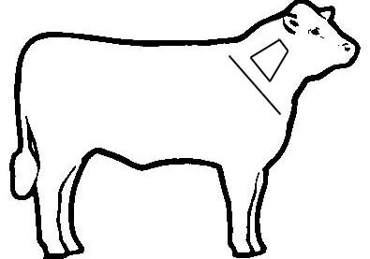
Right Left

Product and  Company | Lot or  Serial # | Exp.  Date | ROA* | Dose | Booster  Date | Withdrawal  Date
1.
2.
3.
4.
5.
6.
7.
8.
*ROA – Route of Administration

Comments:

