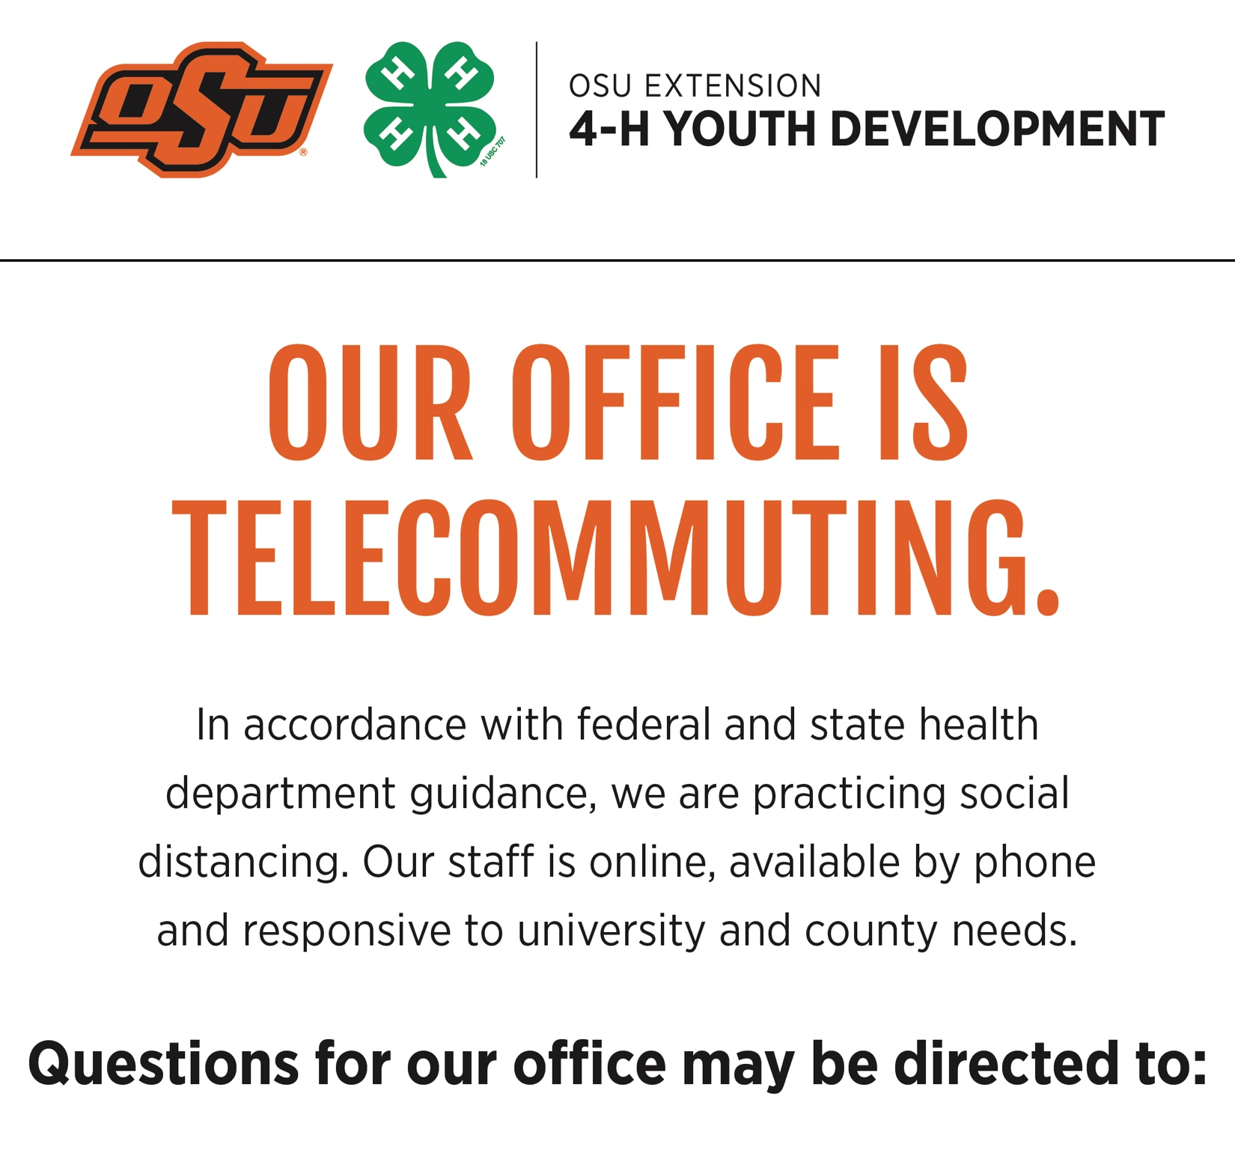
Name 1 Here | Phone.Number.Here | email@okstate.edu
Name 2 (if needed) | Phone.Number.Here | email@okstate.edu
Name 3 (if needed) | Phone.Number.Here | email@okstate.edu

Departmentwebsite.okstate.edu

