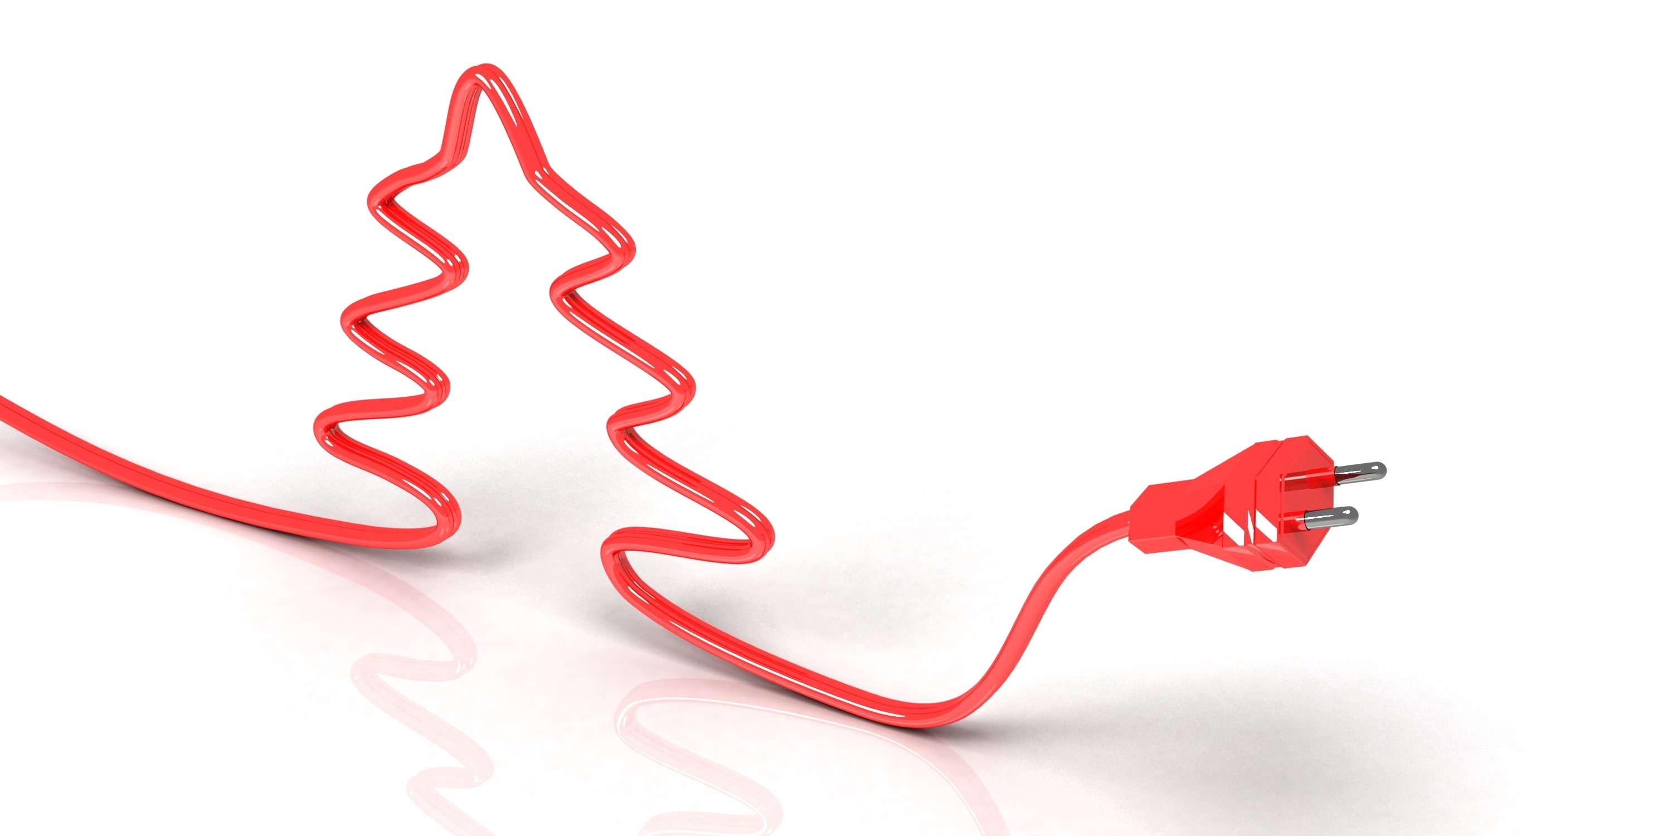 ­­

**NEWSLETTER TITLE**



DATE

Address

Address Goes Here

City, state ZIP

Phone

123-456-7890

Email

Educator 1

Email@okstate.edu

Website

address.okstate.edu

Social Media

Facebook: /PageName

Twitter: @twitterhandle

Instagram: @instagramname

# **XYZ County Extension Office**

It is the time of year to trek up to the attic or down to the basement to bring out all of the treasured holiday decorations, many of which have great sentimental value. The multiple houses in the Christmas village have always been a favorite, along with the light-up garland for the mantle.

As you begin to get out all of these beautiful light up decorations and the Christmas tree lights, homeowners may realize they come up short on the number of needed electrical outlets.

Gina Peek, Oklahoma State University Cooperative Extension housing and consumer specialist, said before you stretch extension cords all around the room in your effort to deck the halls, be sure to keep electrical safety in mind.

“Extension cords are a great option so you can get all of your favorite decorations plugged in. However, using them safely is paramount,” Peek said. “Obviously, we need to keep electrical safety in mind all year long, but it’s essential at the holiday season simply due to the extra things that require electricity.”

She recommends homeowners use only lights and extension cords that are safety-certified by a recognized testing agency such as Underwriters Laboratory (UL). Also, if you are using lights from previous years, be sure to check for any damage before reusing.

“If you find some lights with frayed wires, loose connections or broken or cracked sockets, throw them away,” she said. “These are dangerous and can cause a fire.”

Be sure to read and follow the manufacturer’s instructions for using tree lights. Lights should be fastened to the tree, but not with conductive wire. Bulbs should not be in direct contact with needles or branches on natural trees. Although newer lights,

continued on page 2

including LEDs, do not emit a lot of heat, it could eventually be enough to dry out the tree limbs.

When using lights this holiday season, be sure to select lights appropriately. Use indoor lights indoors and outdoor lights outside. Take the lights down when the holidays are over; these lights are not designed for prolonged exposure to the elements.

“It’s important to never overload wall outlets or extension cords. Connect lights to power strips that have several outlets and a built-in circuit breaker,” Peek said. “Extension cords should never be run under carpet or rugs. The cords could become frayed after being walked on repeatedly, which can be a fire hazard. Also, be careful about putting extension cords across walkways as they can be a tripping hazard. Try to run cords along the wall.”

With a few extra devices plugged into the outlets, you might see a spike in your utilities bill. To help save on the electric bill, use LED lights because they use about 90 percent less electricity than a standard string of incandescent lights. LED holiday lights are typically a bit more expensive, but may pay for themselves in the long run. Consumers also can take advantage of sales after the holidays and stock up for next year.

“Lighting and decorations are a big part of making the holiday festive, and when used safely and properly, they can be enjoyed all season long,” Peek said.

# **In this issue**

# **Be aware of electrical safety during the holiday season**

## **Electrical safety** continued from page 1

- Ipsum



# XYZ County Extension Office

Address Goes Here

City, ST ZIP

Oklahoma State University, as an equal opportunity employer, complies with all applicable federal and state laws regarding non-discrimination and affirmative action.  Oklahoma State University is committed to a policy of equal opportunity for all individuals and does not discriminate based on race, religion, age, sex, color, national origin, marital status, sexual orientation, gender identity/expression, disability, or veteran status with regard to employment, educational programs and activities, and/or admissions.  For more information, visit <https://eeo.okstate.edu>.

Issued in furtherance of Cooperative Extension work, acts of May 8 and June 30, 1914, in cooperation with the U.S. Department of Agriculture, Director of Oklahoma Cooperative Extension Service, Oklahoma State University, Stillwater, Oklahoma. This publication is printed and issued by Oklahoma State University as authorized by the Vice President for Agricultural Programs and has been prepared and distributed at a cost of 000 cents per copy.

**If you put content here, rotate it 180 degrees so it will be right-side up when folded. Don’t forget to update cost statement!**